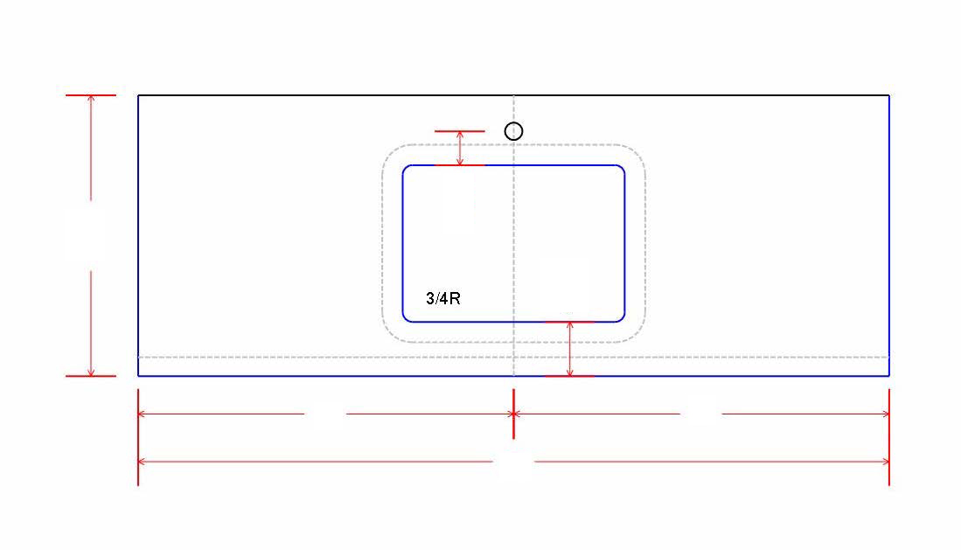

1. MATERIAL COLOR:
2. THICKNESS: :
3. SINK MODEL #:
4. BACKSPLASH: Yes No

- BACKSPLASH HEIGHT:

- CUT TO 2CM: Yes No

5. NOTES:

